ASSIGNMENT:7.3
NAME:C.ANUKYA REDDY
ROLL NO:2303A52452
BATCH:42
TASK 1: Fixing Syntax Errors
PROMPT:
- Prompt sent to AI: "Fix the syntax error in this Python function and show a corrected version plus a brief explanation: def add(a,b) return a+b"
CODE:
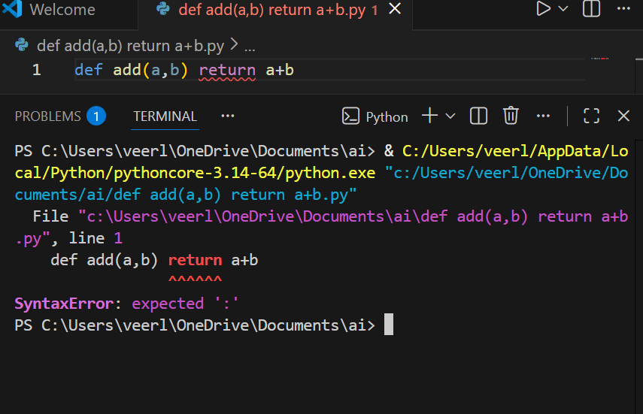
CORRECTED CODE:
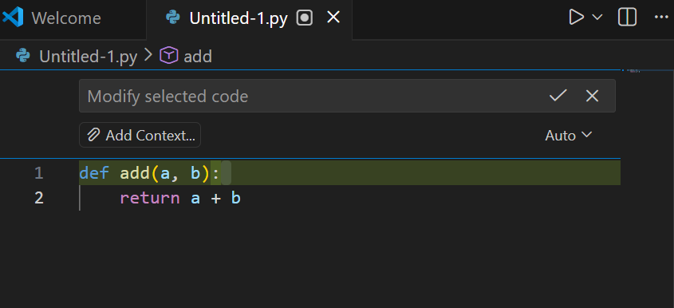
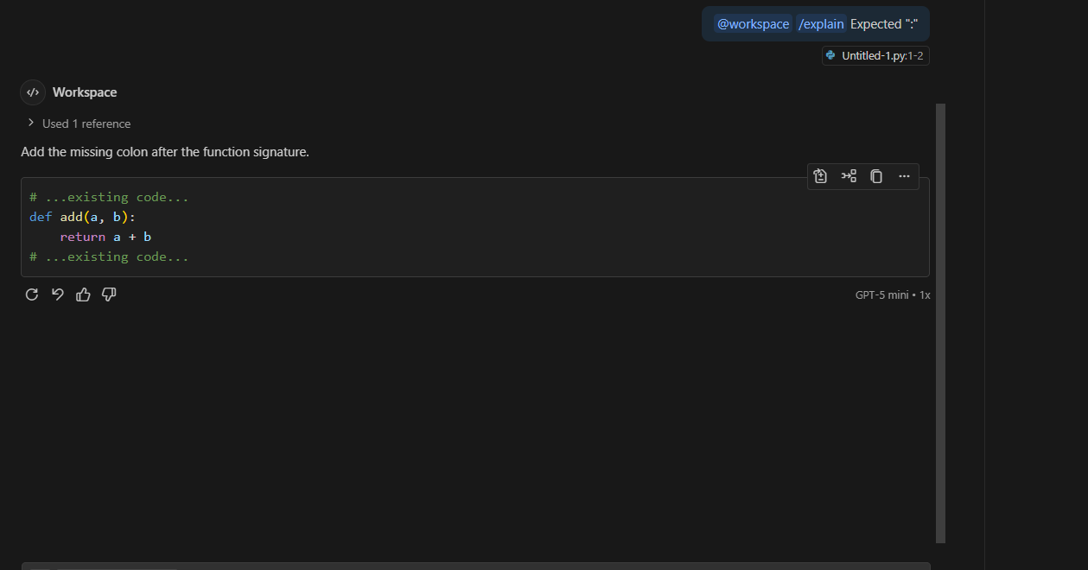
JUSTIFICATION:
Missing colon after the function header caused the parser to see `return` on the same line and raise a SyntaxError.
Adding `:` (writing `def add(a, b):`) correctly starts the function suite so the following indented `return` is valid.
With the colon added the file compiles and the function runs as expected (e.g., add(2, 3) → 5).
TASK 2: Debugging Logic Errors in Loops
PROMPT:
Find the logic error causing an infinite loop in this function, fix it, and return the corrected code plus a one-line explanation.
def count_down(n): while n >= 0: print(n); n += 1
CODE:
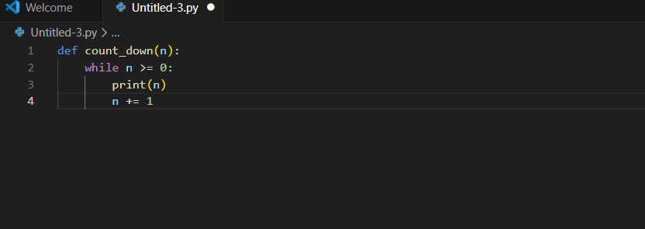
CORRECTED CODE:
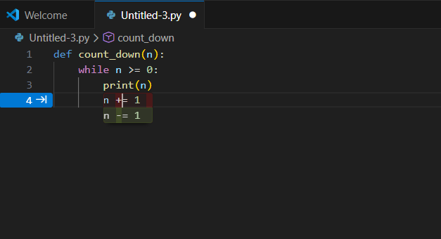
JUSTIFICATION:
Incrementing `n` inside `while n >= 0` moves `n` away from the exit condition, so the loop never becomes false and runs infinitely.
Changing to `n -= 1` (or using `for i in range(n, -1, -1)`) decrements toward the exit condition so the loop will terminate.
TASK 3: Handling Runtime Errors (Division by Zero)
PROMPT:
"Find the runtime error in this function and provide a corrected version that safely handles division-by-zero using try/except. Return runnable code and a brief explanation:
CODE:
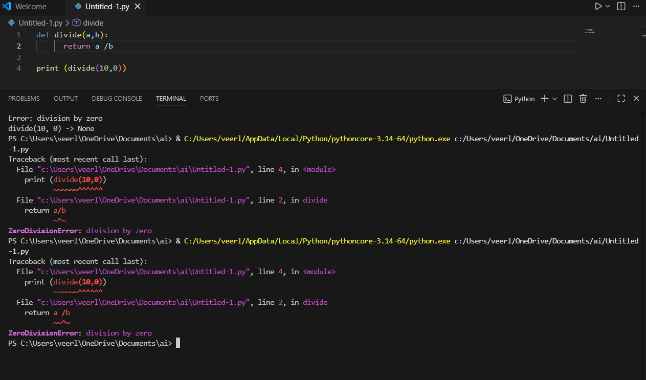
CORRECTED CODE:
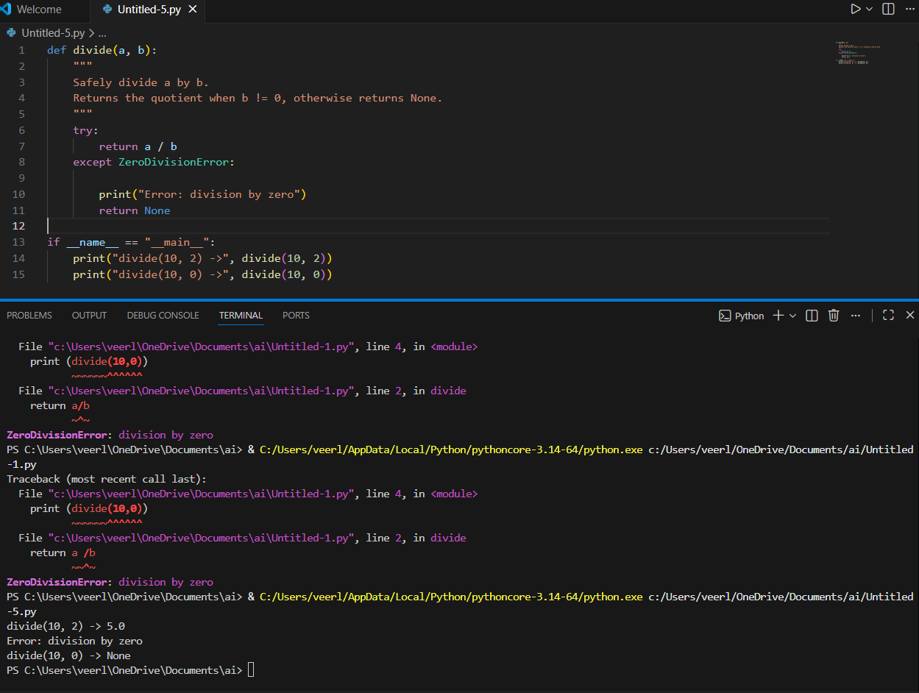
JUSTIFICATION:
Original code raises ZeroDivisionError when b == 0, causing the program to crash.
Wrapping the division in try/except catches the error so the function can handle it (e.g., print a message and return None) instead of terminating.
TASK 4: Debugging Class Definition Errors
PROMPT:
Find and fix the bug in this class constructor, explain why `self` is required, and return corrected runnable code plus a short justification.
class Rectangle: def __init__(length, width): self.length = length; self.width = width
CODE:
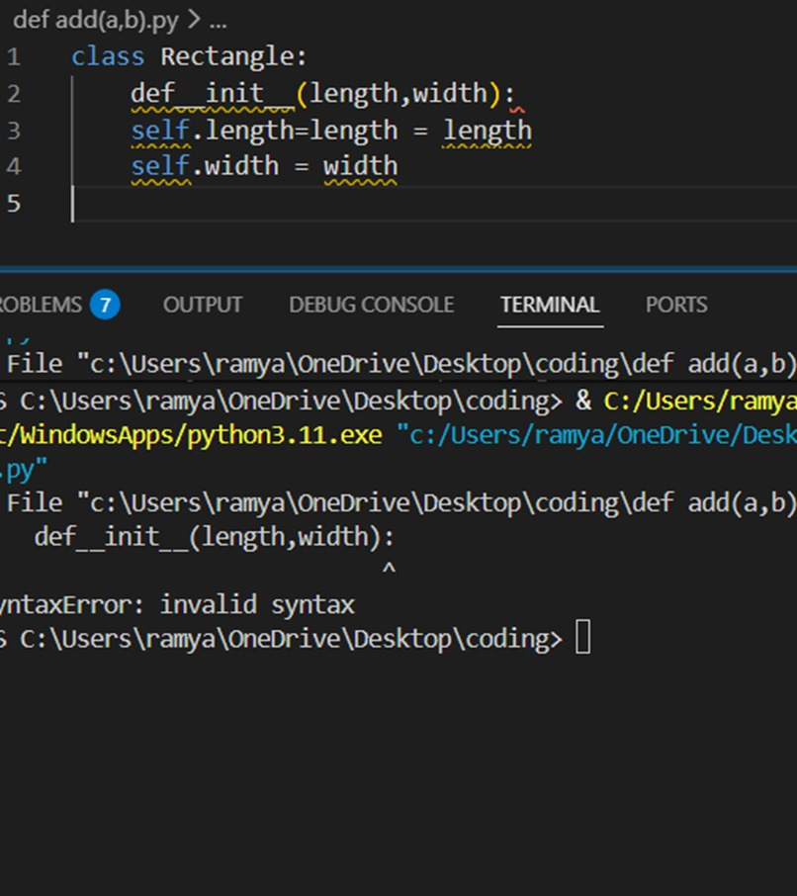
CORRECTED CODE:
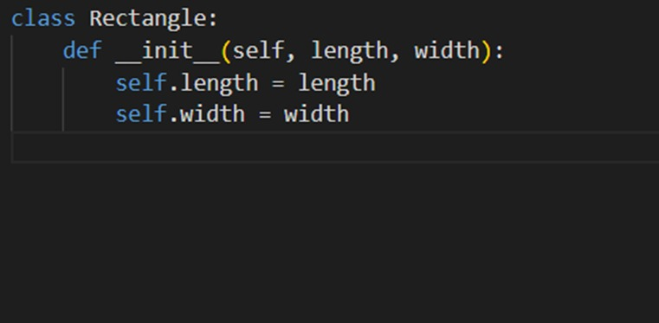
JUSTIFICATION:
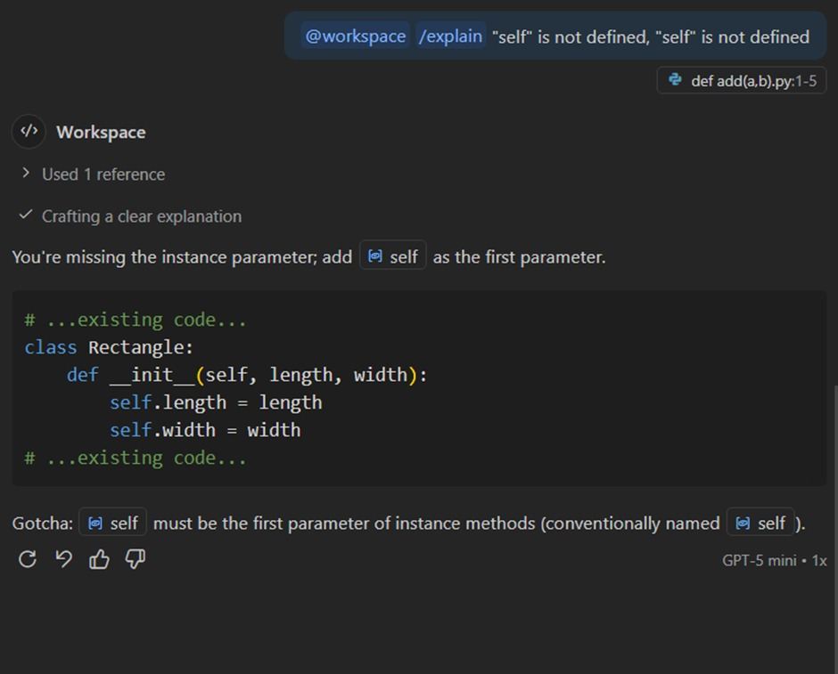
TASK 5: Resolving Index Errors in Lists
PROMPT:
Find the IndexError in the following code and produce corrected, runnable Python that safely handles out-of-range list access using bounds checking or try/except. Include a one-line usage example demonstrating the fix and a two-line justification explaining why your approach prevents crashes.
CODE:
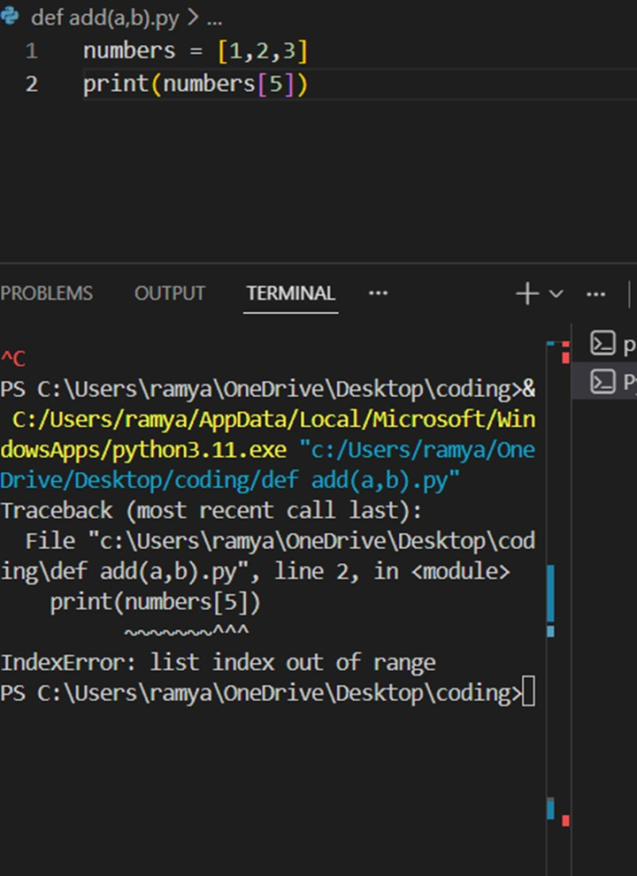
CORRECTED CODE:
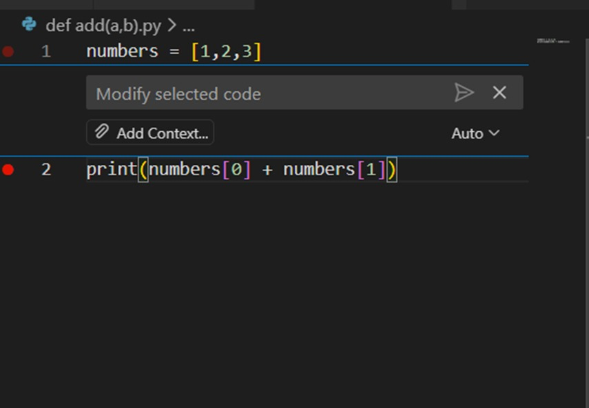
JUSTIFICATION:
The crash happens since the index is outside the list range. Bounds checking or try/except prevents the error and ensures safe access.

